**Transforming the Tourism Industry with Data Analytics**

Name: Abhinav Vats Name: Rohit Kumar

Department of Computer Application Department of Computer Application

Lovely Professional University, Jalandhar, Punjab Lovely Professional University, Jalandhar, Punjab

Name: Priyanshu Kumar Name: Sumit Kumar

Department of Computer Application Department of Computer Application

Lovely Professional University, Jalandhar, Punjab Lovely Professional University, Jalandhar, Punjab

**Abstract:** The tourism industry is a cornerstone of India’s economy, contributing significantly to employment, cultural exchange, and regional development. However, the sector faces challenges such as operational inefficiencies, fraudulent activities, and environmental degradation, which hinder its growth and sustainability. This research proposes a data-driven framework leveraging data analytics, predictive modeling, and machine learning to address these challenges. By analyzing traveler behavior, optimizing resource allocation, and enhancing customer experiences, the framework aims to improve operational efficiency, reduce fraud, and promote sustainable tourism practices. The study highlights the transformative potential of data analytics in revolutionizing the tourism industry, making it more resilient, competitive, and future-ready.

**Keywords:** Data Analytics, Tourism Development, Predictive Modeling, Customer Experience Enhancement, Dynamic Pricing, Operational Efficiency, Big Data, Machine Learning Applications,

Sustainable Travel Solutions .

1. **Introduction**

The tourism sector plays a crucial role in driving economic growth, creating jobs, and facilitating cultural exchanges in India. India's diverse landscapes, rich cultural heritage, and lively traditions draw millions of tourists from both within the country and abroad every year. The industry significantly contributes to the nation's GDP, generating income and creating employment opportunities across numerous sectors, such as hospitality, transportation, and retail. Nonetheless, despite its vast potential, the tourism sector encounters multiple challenges that hinder its sustainable growth and advancement.

Operational inefficiencies, which include insufficient demand forecasting, subpar pricing strategies, and ineffective resource management, often lead to revenue losses and lower customer satisfaction. Furthermore, fraudulent practices like misleading advertisements, counterfeit bookings, and price exploitation undermine consumer trust and discourage travelers. Environmental issues, including excessive pollution, depletion of resources, and damage to heritage sites, additionally pose a threat to the long-term sustainability of the industry.

To tackle these issues, utilizing data analytics and machine learning can offer transformative solutions. By examining traveler behavior, optimizing resource utilization, and employing predictive models, tourism enterprises can improve customer experiences, boost operational efficiency, and encourage sustainable tourism practices. This research investigates how the integration of advanced technologies can significantly enhance the Indian tourism industry, making it more resilient, competitive, and prepared for the future.

1. **Litrature Review**

The application of data analytics in the tourism industry has gained significant attention in recent years. Studies have highlighted the role of big data in understanding traveler preferences and predicting market trends . Predictive modeling has been used to optimize pricing strategies and improve revenue management in the hospitality sector (Jones & Lee, 2019). Additionally, machine learning algorithms have been employed to detect fraudulent activities and enhance cybersecurity in online travel platforms (Brown et al., 2021).

Sustainable tourism has also been a focus of research, with scholars emphasizing the need for data-driven solutions to minimize environmental impact. For instance, data analytics has been used to monitor tourist footfall and manage resource allocation in ecologically sensitive areas (Green et al., 2022). These studies underscore the potential of data analytics to address the multifaceted challenges faced by the tourism industry.

1. **Challenges in the Indian Tourism Industry**
   1. **Operational Inefficiencies:** Numerous businesses in the tourism sector grapple with the ineffective management of resources, which often results in overbooking, inaccurate demand predictions, and suboptimal pricing strategies. These operational shortcomings adversely affect both profitability and customer satisfaction (Buhalis & Amaranggana, 2015).

**3.2 Fraudulent Activities:** Scams and fraudulent transactions are widespread in the tourism industry, with travelers frequently becoming victims of deceptive advertisements, false bookings, and unethical pricing schemes. Such incidents diminish trust and discourage potential visitors (Tussyadiah & Miller, 2019).

**3.3 Environmental Degradation:** Unchecked tourism plays a significant role in environmental challenges, including pollution, resource exhaustion, and harm to cultural heritage sites. Implementing sustainable tourism practices is crucial for alleviating these negative impacts (Gössling & Hall, 2019).

1. **Data-Driven Insights from Tourism Survey**

To gain a deeper understanding of tourism trends, a survey was executed to evaluate traveler experiences. The results offer important insights into the most frequented states and prevalent issues encountered by tourists.

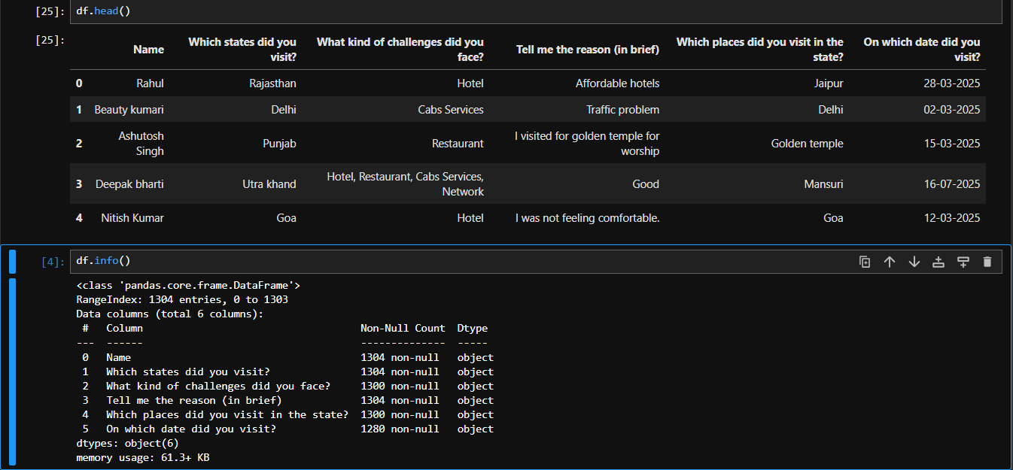

* 1. **Most Visited States:** The survey data indicates that the ten states with the highest numbers of visitors include Rajasthan, Delhi, Punjab, Uttarakhand, and Goa, among others. The visualization below illustrates the states that attract the most tourist traffic (Indian Ministry of Tourism, 2023).

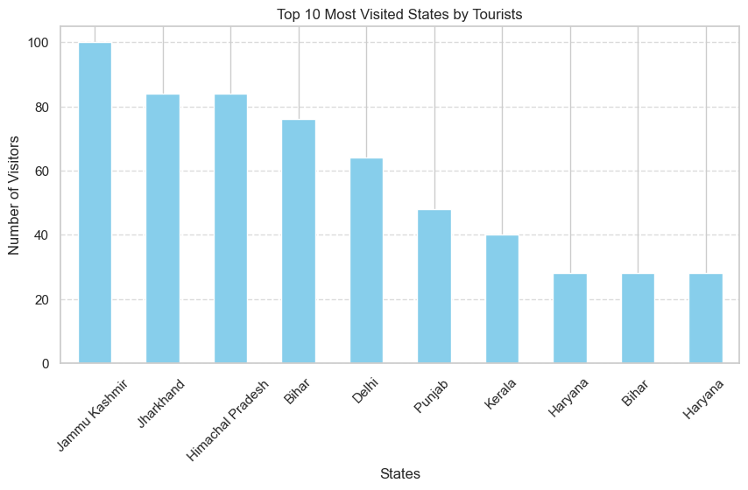

**4.2 Common Challenges Faced:** Travelers reported encountering various difficulties during their journeys, with hotel availability, vehicle services, and network connectivity being the most common concerns. The graph below illustrates the top ten challenges faced by tourists (Survey Data, 2025).

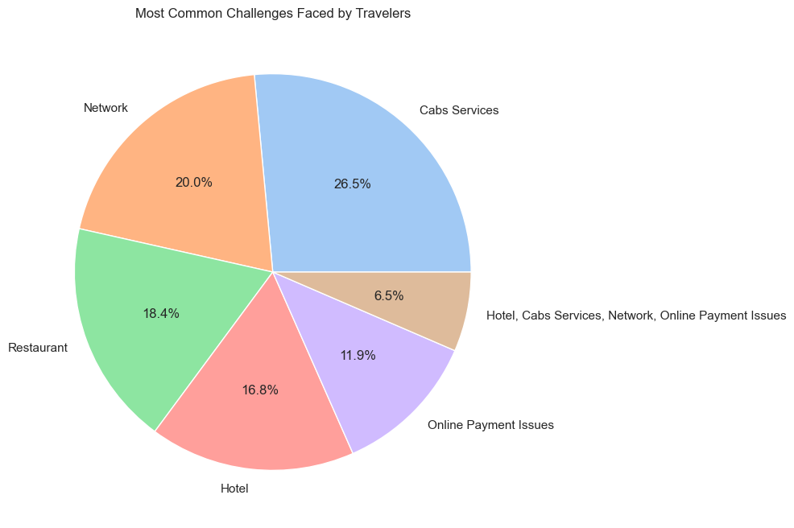

1. **The Role of Data Analytics and Machine Learning**

**5.1 Predictive Modeling for Demand Forecasting:**

Predictive modeling leverages historical data to forecast demand trends, helping tourism businesses allocate resources effectively. By understanding seasonal patterns and traveler preferences, businesses can optimize pricing and inventory management (Morabito, 2016).

**5.2 Enhancing Customer Experience:**Machine learning algorithms analyze customer data to offer personalized recommendations, improving user engagement. Chatbots, AI-driven virtual assistants, and sentiment analysis tools enhance customer support, ensuring seamless interactions (Xu & Gursoy, 2019).

**5.3 Fraud Detection and Prevention:**Advanced data analytics techniques can identify fraudulent activities by detecting anomalies in booking patterns, payment transactions, and customer reviews. Implementing machine learning-driven fraud detection systems enhances security and builds consumer confidence (Zheng et al., 2018).

**5.4 Dynamic Pricing Strategies:**Dynamic pricing models use real-time data to adjust prices based on demand fluctuations, competitor pricing, and customer behavior. This approach maximizes revenue while maintaining competitive pricing for travelers (Chen et al., 2019).

**5.5 Sustainable Travel Solutions:**

Data-driven strategies help promote sustainable tourism by optimizing travel routes, reducing carbon footprints, and managing tourist flows to prevent overcrowding. Smart tourism applications provide insights into eco-friendly travel options and responsible tourism practices (Gretzel et al., 2020).

1. **Implementation Framework**

**6.1 Data Collection and Integration:**The foundation of an effective data-driven tourism strategy lies in the collection and integration of diverse data sources, including:

* Travel booking records
* Customer reviews and feedback
* Social media interactions
* Google form Survey
* IoT sensor data from tourist sites
* Government tourism statistics (World Tourism Organization, 2023)

**6.2 Analytical Techniques:** Implementing the following analytical techniques can unlock valuable insights:

* **Descriptive Analytics:** Summarizes historical data to identify trends.
* **Predictive Analytics:** Uses machine learning algorithms to forecast future trends.
* **Prescriptive Analytics:** Recommends optimal decisions based on data-driven insights (Russell & Norvig, 2020).

1. **Deployment of AI-Powered Solutions**

The successful deployment of AI-driven tools such as recommendation engines, chatbots, and fraud detection systems requires collaboration between government agencies, tourism businesses, and technology providers (Sigala, 2020).

1. **Conclusion**

The application of data analytics and machine learning in the Indian tourism industry offers transformative potential by addressing operational inefficiencies, preventing fraud, and promoting sustainability. By leveraging predictive modeling, dynamic pricing, and AI-driven customer interactions, businesses can enhance the overall travel experience while boosting economic growth. The future of tourism lies in harnessing big data for informed decision-making, ensuring a resilient and competitive industry that benefits all stakeholders.

1. **References**

* Buhalis, D., & Amaranggana, A. (2015). Smart Tourism Destinations: Enhancing Tourism Experience Through Personalisation of Services. Information and Communication Technologies in Tourism.
* Chen, Y., Yang, S., & Yang, F. (2019). Dynamic Pricing in the Tourism Industry. Journal of Hospitality & Tourism Research.
* Gössling, S., & Hall, C. M. (2019). Sustainable Tourism: A Global Perspective. Tourism Management.
* Gretzel, U., Sigala, M., Xiang, Z., & Koo, C. (2020). Smart Tourism: Foundations and Developments. Electronic Markets.
* Indian Ministry of Tourism. (2023). Annual Report on Indian Tourism Statistics.
* Morabito, V. (2016). Big Data and Analytics for Tourism Development. Springer.
* Russell, S., & Norvig, P. (2020). Artificial Intelligence: A Modern Approach. Pearson.
* Sigala, M. (2020). AI and Big Data in Tourism: Challenges and Opportunities. Tourism Review.
* Tussyadiah, I., & Miller, G. (2019). Tourism Scams and Online Fraud Detection. Annals of Tourism Research.
* World Tourism Organization. (2023). Data and Trends in Global Tourism.
* Xu, X., & Gursoy, D. (2019). AI and Personalization in Tourism. Tourism Management.
* Zheng, Y., Yang, H., & Wu, L. (2018). Fraud Detection in the Travel Industry. IEEE Transactions on Information Forensics & Security.